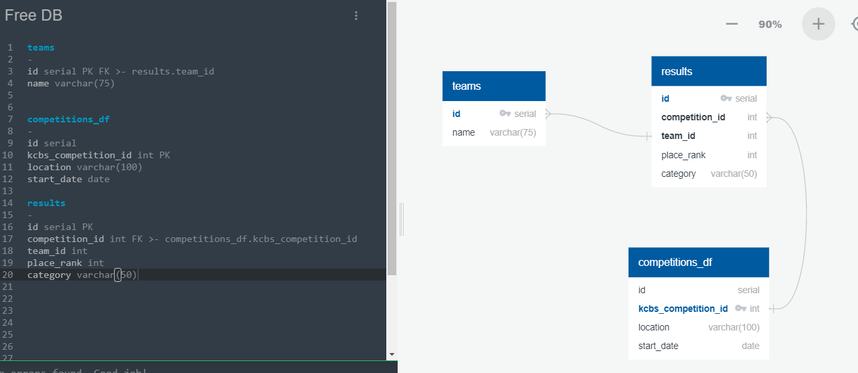

Postgres Export

-- Exported from QuickDBD: https://www.quickdatabasediagrams.com/

-- Link to schema: https://app.quickdatabasediagrams.com/#/d/t4aEDe

-- NOTE! If you have used non-SQL datatypes in your design, you will have to change these here.

CREATE TABLE "teams" (

"id" serial NOT NULL,

"name" varchar(75) NOT NULL,

CONSTRAINT "pk_teams" PRIMARY KEY (

"id"

)

);

CREATE TABLE "competitions_df" (

"id" serial NOT NULL,

"kcbs_competition_id" int NOT NULL,

"location" varchar(100) NOT NULL,

"start_date" date NOT NULL,

CONSTRAINT "pk_competitions_df" PRIMARY KEY (

"kcbs_competition_id"

)

);

CREATE TABLE "results" (

"id" serial NOT NULL,

"competition_id" int NOT NULL,

"team_id" int NOT NULL,

"place_rank" int NOT NULL,

"category" varchar(50) NOT NULL,

CONSTRAINT "pk_results" PRIMARY KEY (

"id"

)

);

ALTER TABLE "teams" ADD CONSTRAINT "fk_teams_id" FOREIGN KEY("id")

REFERENCES "results" ("team_id");

ALTER TABLE "results" ADD CONSTRAINT "fk_results_competition_id" FOREIGN KEY("competition_id")

REFERENCES "competitions_df" ("kcbs_competition_id");

select teams.*, results.*, kc_bbq.*

from kc_bbq inner join teams on kc_bbq.id = teams.id

inner join results on kc_bbq.kcbs_competition_id = results.competition_id

select teams.id, teams.name, results.id, results.competition_id, results.team_id, results.place_rank, results.category, kc_bbq.id, kc_bbq.kcbs_competition_id, kc_bbq.location

from kc_bbq inner join teams on kc_bbq.id = teams.id

inner join results on kc_bbq.kcbs_competition_id = results.id

select teams.name,

teams.id,

results.place_rank,

results.category,

kc_bbq.location,

kc_bbq.start_date

from kc_bbq inner join teams on kc_bbq.id = teams.id

inner join results on kc_bbq.kcbs_competition_id = results.competition_id